Dessa Shapiro

4/11/20

Period 4/6

The Climb

I’m reading the book *Into Thin Air* by Jon Krakauer, and I am currently focusing on chapters 5-9. So far in these chapters, they are starting to get higher on the mountain. They have just reached one of the most dangerous parts of the climb, a huge ice wall. “ Because the climbing route wove under, around, and between hundreds of these unstable towers, each trip through the Icefall was a little like playing a round of Russian roulette”(pg.83) I think that this part of the text shows a clear understanding of how the author can allow the reader to visualize the scene. The author is using figurative language to maximize the effects of the scene on the audience. I felt the strongest connections with the metaphor because I thought that it was a good expression of what this moment felt like.

The author's purpose is not clear through the book so far, but I think that the author intends to share his experience with others in a way they relate and can empathize with him. And I also think that in these chapters he might be wanting to express how much climbing means to him. And I noticed he tends to use an Omniscient monologue by giving a lot of background information about other climbers ”It was as if there were an unspoken agreement on the mountain to pretend that these desiccated remains weren’t real-as if none of us dared to acknowledge what was at stake here.”(pg.111) I think this passage supports how much climbing means to him because it expresses his opinion of the risk he was willing to take to reach his goal. The author is making it clear that he understands the mountain and it allows me to trust him more because it shows me that he has done the research and understands what he’s talking about. In the book so far I feel that I’ve learned a lot about how the author felt when he went through this and understood his motivation. And this allows me to better connect to the text and comprehend the author's emotions.

I think that the writing stood out to me because the author includes many different perspectives and styles in the writing that make me find the story more interesting. I found that the writer included both informational and personal perspectives and this shows me that as the writer wrote the text he was reflecting on the experience. I think that since this is a unique experience the author is writing about he found a way to communicate through exclamation and information. But he also writes about his emotions and experience through the use of figurative language. And I find it helpful when reading and understanding the text to get both of those perspectives. “I quickly came to understand that climbing Everest was primarily about enduring pain. And subjecting ourselves to week after week of toil, tedium, and suffering, it struck me that most of us were probably seeking, above all else, something like a state of grace.”(pg.140) For me, I think this passage is a good example of how the author used an explanation to connect with the reader and win them over. As I read through this book I thought that he was crazy for doing this, and I still don’t understand him because I’ve never had a passion for climbing or hiking. But when reading parts of the text that give a broader picture of what climbing Everest means to them, I feel that I’m better able to put myself in a different perspective.

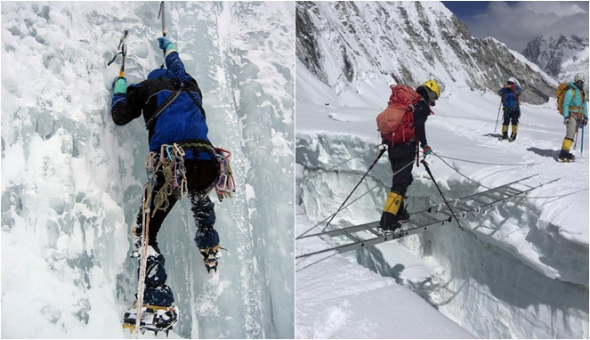

Picture of the Kubur Icefall on Everest